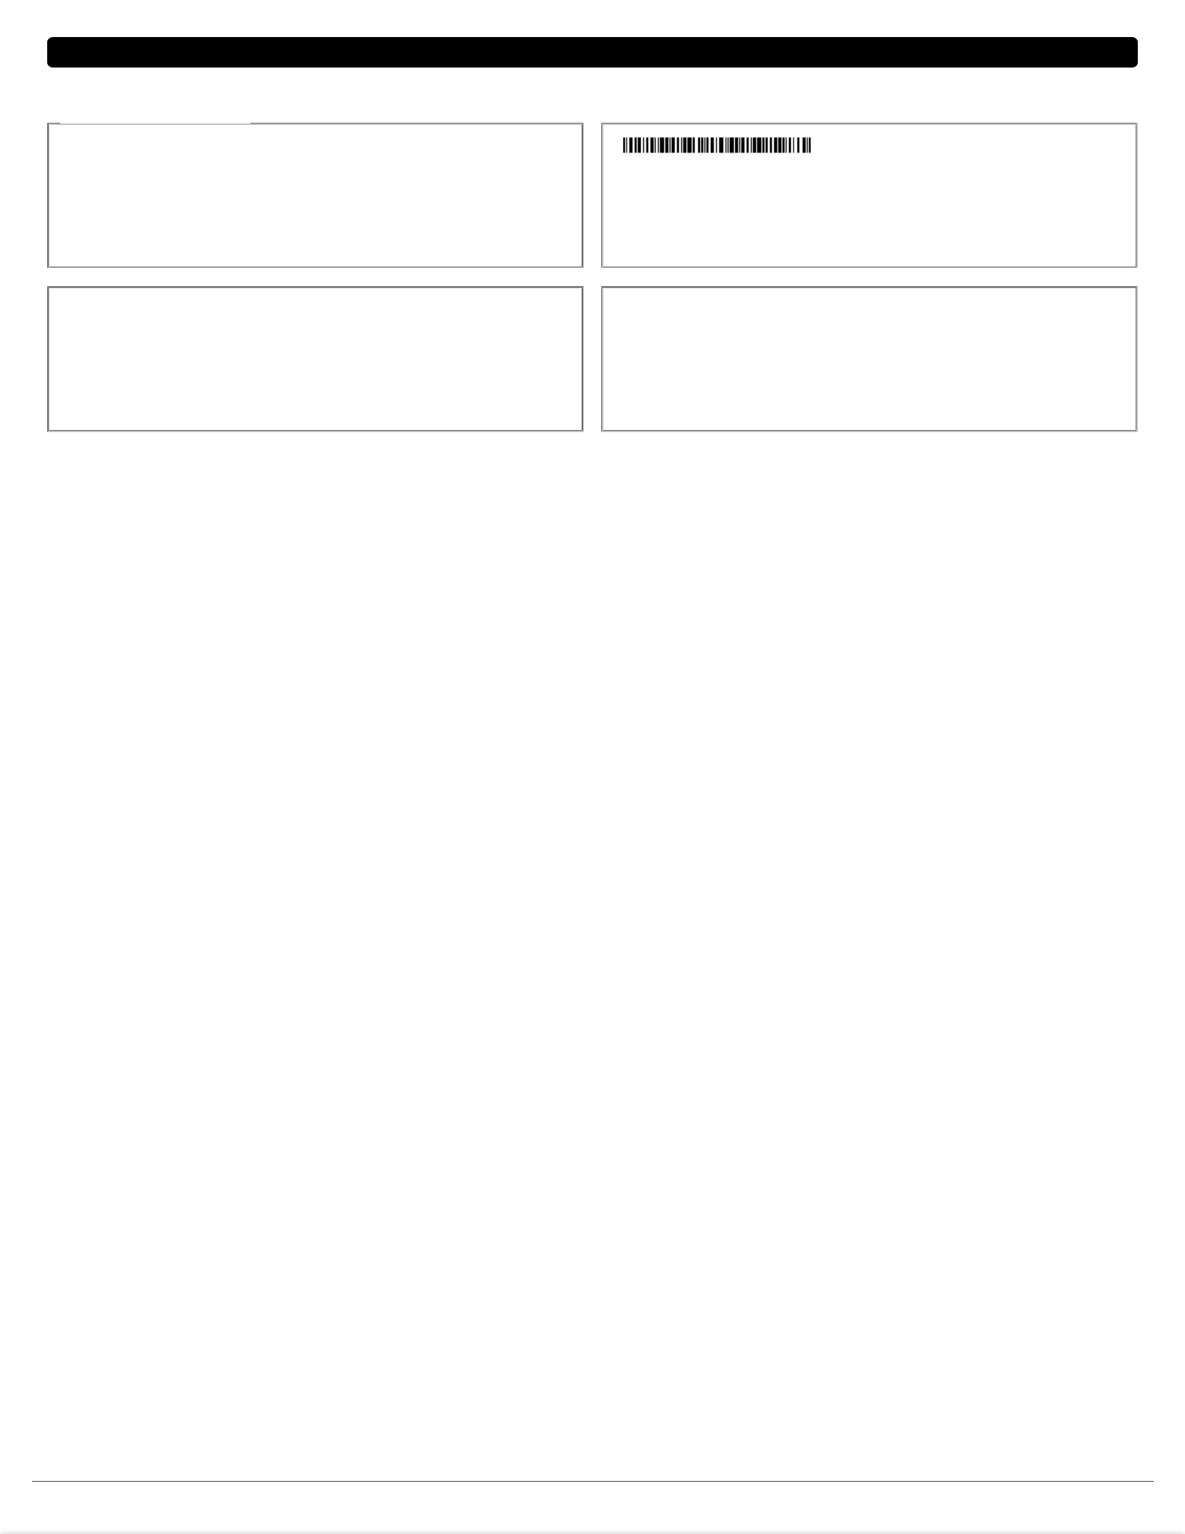**CHANNEL PARTNER OF SHREE MARUTI COURIER SERVICES PVT. LTD.**

**Channel PartnerDHARTI ENTERPRISES**

**PULLAPPADY ROAD, A K TOWER ERNAKULAM**

**TAX INVOICE (ORIGINAL FOR RECIPIENT)**

|  |  |  |  |  |  |  |  |  |  |
| --- | --- | --- | --- | --- | --- | --- | --- | --- | --- |
|  | **Tax Details** | |  | **Bill Detail** | |  |  |  |  |
|  | COURIER SERVICE SAC | | : 996812 |  |  |  |  |  |  |
|  | DESCRIPTION OF SERVICE | | : COURIER SERVICE | BILL NO |  | : 2122/321285/0048 | | |  |
|  | GST NO |  | : 32AKDPB9840L1Z6 | BILL DATE | | : 30/04/2021 | |  |  |
|  | P.A.N |  | : AKDPB9840L | PERIOD |  | : 01/04/2021 TO 30/04/2021 | | | |
|  | STATE - STATE CODE | | : KERALA - 32 |  |  |  |  |  |  |
|  | **Consignor Details** | |  | **Place of Supply** | | |  |  |  |
|  | NAME | : **SHIPMENT SOLUTIONS PVT LTD** | | NAME | : **SHIPMENT SOLUTIONS PVT LTD** | | | | |
|  | ADDRESS : 4ST FLOOR SHREE SIDDHI VINAYAKA APT, | | | ADDRESS : 4ST FLOOR SHREE SIDDHI VINAYAKA APT, | | | | | |
|  | GSTIN | ERNAKULAM, KERALA | |  | ERNAKULAM, KERALA | | | |  |
|  | : **32AAXCS7126B1ZB** | |  |  |  |  |  |  |
| **Date** | |  |  |  |  |  |  |  |  |
| **No. Consignee** | | | **Address of Delivery Area** | **Doc No.** |  | **Value Charges** | | **Weight** | **Remarks** |
| **01/04/2021** | |  |  |  |  |  |  |  |  |
| 1 | SEASAGA ENTS- FTS | | VASHI | 21018200000032 | | 0.00 | 300.00 | 100 Gms | DOX |
| **05/04/2021** | |  |  |  |  |  |  |  |  |
| 2 | FORSTAR FROZEN- FTS | | MUMBAI | 21018200000341 | | 0.00 | 300.00 | 100 Gms | DOX |
| **07/04/2021** | |  |  |  |  |  |  |  |  |
| 3 | SEASAGA ENTS- FTS | | VASHI | 21018200000563 | | 0.00 | 300.00 | 200 Gms | DOX |
| 4 | FORSTAR FROZEN | | MUMBAI | 21018200000564 | | 0.00 | 300.00 | 200 Gms | DOX |
| **08/04/2021** | |  |  |  |  |  |  |  |  |
| 5 | SEASAGA ENTS- FTS | | VASHI | 21018200000570 | | 0.00 | 300.00 | 100 Gms | DOX |
| **13/04/2021** | |  |  |  |  |  |  |  |  |
| 6 | SEASAGA ENTS- FTS | | VASHI | 21018200000771 | | 0.00 | 300.00 | 50 Gms | DOX |
| **16/04/2021** | |  |  |  |  |  |  |  |  |
| 7 | SANCHITA MARINE-FTS | | MUMBAI | 21018200001062 | | 0.00 | 300.00 | 100 Gms | DOX |
| 8 | FORSTAR FROZEN- FTS | | MUMBAI | 21018200001063 | | 0.00 | 300.00 | 100 Gms | DOX |
| **20/04/2021** | |  |  |  |  |  |  |  |  |
| 9 | FORSTAR FROZEN- FTS | | MUMBAI | 21018200001195 | | 0.00 | 300.00 | 100 Gms | DOX |
| **21/04/2021** | |  |  |  |  |  |  |  |  |
| 10 | SEASAGA ENTS- FTS | | VASHI | 21018200001256 | | 0.00 | 300.00 | 100 Gms | DOX |
| **27/04/2021** | |  |  |  |  |  |  |  |  |
| 11 | FORSTAR FROZEN- FTS | | MUMBAI | 21018200003747 | | 0.00 | 300.00 | 100 Gms | DOX |
| **29/04/2021** | |  |  |  |  |  |  |  |  |
| 12 | SEASAGA ENTS- FTS | | VASHI | 21018200003680 | | 0.00 | 300.00 | 100 Gms | DOX |
| 13 | FORSTAR FROZEN- FTS | | MUMBAI | 21018200003681 | | 0.00 | 300.00 | 100 Gms | DOX |
| **30/04/2021** | |  |  |  |  |  |  |  |  |
| 14 | BALA-FTS |  | VASHI | 21018200003682 | | 0.00 | 300.00 | 50 Gms | DOX |

**This is computer generated invoice signature is not required** **01/05/2021 10:54:42** **Page No. 1 / 2**

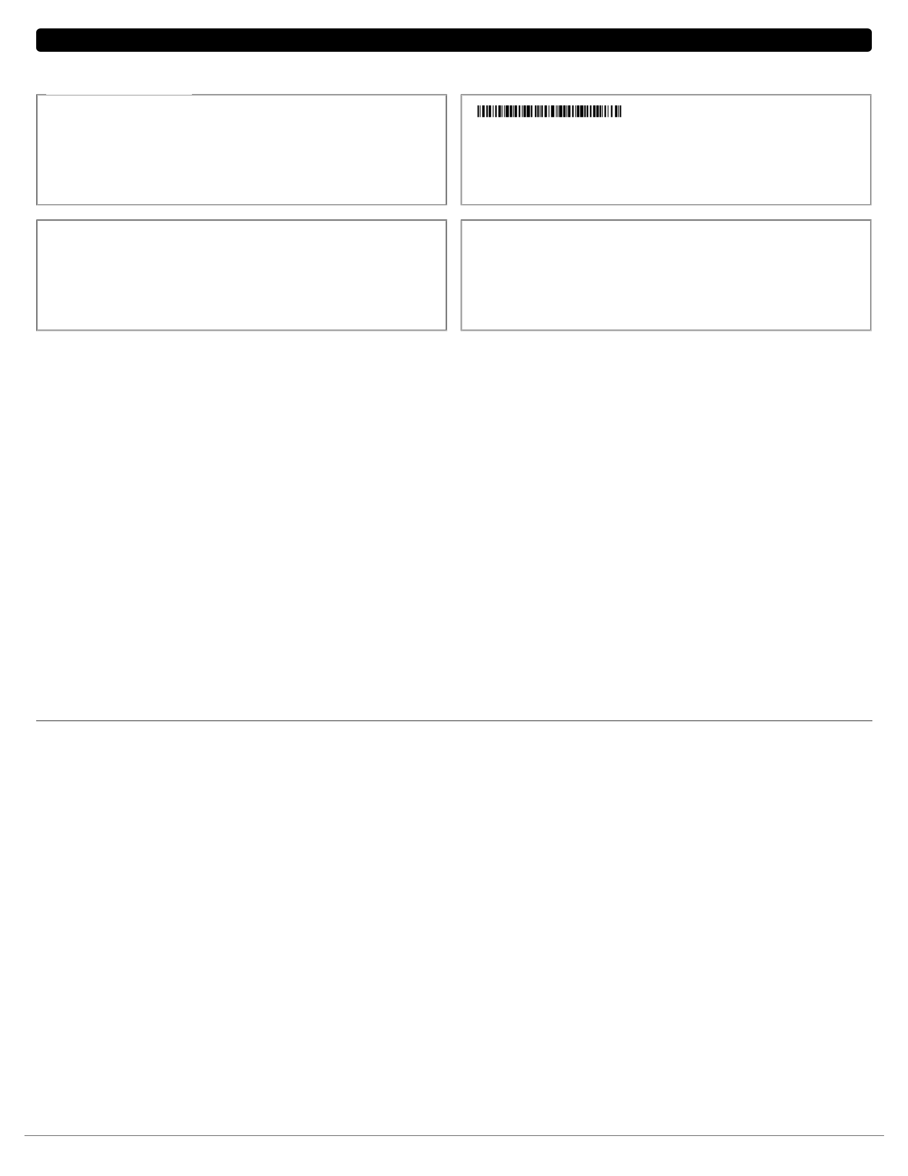**CHANNEL PARTNER OF SHREE MARUTI COURIER SERVICES PVT. LTD.**

**Channel PartnerDHARTI ENTERPRISES**

**PULLAPPADY ROAD, A K TOWER ERNAKULAM**

**TAX INVOICE (ORIGINAL FOR RECIPIENT)**

|  |  |  |  |  |
| --- | --- | --- | --- | --- |
| **Tax Details** | |  | **Bill Detail** | |
| COURIER SERVICE SAC | | : 996812 |  |  |
| DESCRIPTION OF SERVICE | | : COURIER SERVICE | BILL NO | : 2122/321285/0048 |
| GST NO |  | : 32AKDPB9840L1Z6 | BILL DATE | : 30/04/2021 |
| P.A.N |  | : AKDPB9840L | PERIOD | : 01/04/2021 TO 30/04/2021 |
| STATE - STATE CODE | | : KERALA - 32 |  |  |
| **Consignor Details** | |  | **Place of Supply** | |
| NAME | : **SHIPMENT SOLUTIONS PVT LTD** | | NAME: **SHIPMENT SOLUTIONS PVT LTD** | |
| ADDRESS : 4ST FLOOR SHREE SIDDHI VINAYAKA APT, | | | ADDRESS : 4ST FLOOR SHREE SIDDHI VINAYAKA APT, | |
| GSTIN | ERNAKULAM, KERALA | |  | ERNAKULAM, KERALA |
| : **32AAXCS7126B1ZB** | |  |  |

|  |  |  |  |
| --- | --- | --- | --- |
|  | Gross Total: | **₹ 4,200.00** | |
|  | 5.00% Fuel Surcharge: | **₹ 210.00** | |
|  | 0 Rs. Per Doc Charge: | **₹ 0.00** | |
|  | SMS Charge: | **₹ 0.00** | |
|  | Total value of supply: | **₹ 4,410.00** | |
|  | 9% CGST: | **₹ 396.90** | |
|  | 9% SGST/UTGST: | **₹ 396.90** | |
|  | 18% IGST: | **₹ 0.00** | |
| * Note:F='Fast Track',P='Parcel',V='Value Plus' | 1% KERALA FLOOD CESS: | **₹ 0.00** | |
|  | Round Off (Add): | **₹ 0.80** | |
|  | Net Amt: | **₹ 5,203.00** | |
| **Amount in Words : FIVE THOUSAND TWO HUNDRED THREE RUPEES AND ZERO PAISA ONLY** | |  |  |
|  |  | **For, DHARTI ENTERPRISES** | |
| Please make payment in favor of DHARTI ENTERPRISES |  |  |  |
| **Remarks:** |  | **Authorized Signature** | |

Wheather tax payable under reverse charge: "NO"

Kindly check your GSTIN mentioned on the bill if any changes required do intimate the same to our branch within 7 days from receipt of invoice, once GST return are filed no party shall be entertained to add the GSTIN.

**This is computer generated invoice signature is not required** **01/05/2021 10:54:42** **Page No. 2 / 2**